Strategic Planning and Data Exploration in Logistics
Week 1 Task — Strategic Planning Report

By - Yash Kulkarni

- Project Defination –
Scenario - SwiftCart Logistics is a mid-sized e-commerce fulfillment company operating three regional distribution centers (DCs) that serve urban and semi-urban areas, delivering approximately 15,000 orders per week using a mix of company-owned and third-party delivery vehicles. Over the past two quarters, the company has faced three connected problems: on-time delivery rates have declined during peak periods, one distribution center has built up excess inventory of slow-moving items while another frequently runs out of stock, and delivery costs have risen due to inefficient route planning. Leadership wants a data-driven approach to understand these issues and improve overall efficiency before the next peak season.

- Key Performance Indicators (KPI’s)
KPI | What it Measures | Why It Matters
On-Time Delivery Rate (OTD) | % of orders delivered within the promised window | Shows whether customers are getting reliable service
Inventory Carrying Cost (% of value) | Cost of holding stock as a % of total inventory value | Shows how expensive the overstock problem is
Order Fulfillment Cycle Time | Avg. time from order placed to delivered | Captures overall process speed/efficiency
Fleet/Vehicle Utilization Rate | % of vehicle capacity used per trip | Shows if routes/loads are planned efficiently
Delivery Cost per Order | Total delivery cost ÷ number of orders | Ties performance back to cost

- Research –
Public Dataset Used - For this analysis, the DataCo Smart Supply Chain Dataset (a realistic simulated dataset available on Kaggle) will be used as a stand-in for SwiftCart's actual data. It contains order and shipment records across multiple regions, including shipping mode, a pre-labeled "late delivery risk" flag, sales and profit figures, and customer segment/region information. This dataset is well suited to the project because it already tracks delivery lateness (supporting the On-Time Delivery Rate KPI), shipping mode (useful for Fleet Utilization patterns), and regional/segment data (useful for spotting the demand imbalance behind the inventory problem).
The dataset contains 180,519 order records across 53 columns, covering order details, shipping performance, customer information, and product categories.

- Data Science Techniques and Their Application –
Three data science techniques are central to this analysis. Regression will be used to forecast demand at each distribution center, helping address the inventory imbalance by predicting how much stock is actually needed. Clustering will group regions or customer segments by delivery behavior, allowing SwiftCart to treat high-risk or high-volume areas differently rather than applying uniform policies. Optimization techniques will be applied to plan efficient delivery routes and determine optimal inventory levels per DC, directly targeting the delivery cost and stockout problems described in the scenario.

- Regression — predicts demand at each DC, helping fix the inventory imbalance by ordering the right amount
- Clustering — groups regions/customers by delivery behavior, so different areas can be treated differently
- Optimization — finds the most efficient delivery routes and ideal inventory levels per DC

- Strategic Roadmap –
The analysis will follow a structured six-phase process, moving from raw data to actionable, measurable recommendations.

Phase | What Happens
1.Data Collection | Gather order and shipment data (in this project the DataCo  Dataset was used as a stand-in)
2.Data Cleaning | Fix missing values, correct data types, remove duplicates
3.Exploratory Data  Analysis (EDA) | Look at patterns using charts and stats – eg. Delivery delays,  Regions by behavior
4.Predictive Modeling | Use regression to forcast demand and clustering to group  Regions by behavior
5.Optimization | Determine efficient delivery routes and ideal inventory levels  Per distribution center
6.Evaluation & Reporting | Check results against KPI’s and summarize findings for decision-makes

- Data Collection → Data Cleaning → EDA → Predictive Modeling → Optimization → Evaluation & Reporting

Code Illustration & Results
The following python code was written and executed against the DataCo dataset to calculate key metrics supporting the KPI’s defined earlier.unlike theoretical pseudocode,these snippets were run directly and produced real results.

- On-Time Delivery Rate –
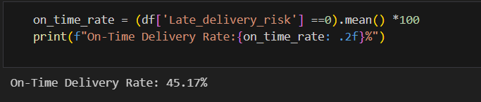

- Result – On-Time Delivery Rate :45.17%
The calculated on-time delivery rate was 45.17%, meaning over half of all orders were flagged as being at risk of late delivery directly reflecting the delivery reliability issues described in SwiftCart scenario.

- Order Fulfillment Cycle Time –
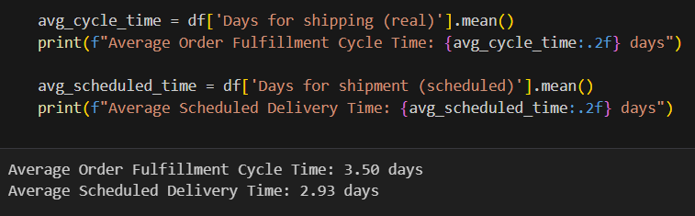

- Result – 3.50 days actual vs 2.93 days scheduled
Orders took 3.50 days on average to fulfill, compared to a scheduled 2.93 days, a gap of roughly 0.57 days, further confirming the on-time delivery challenge.

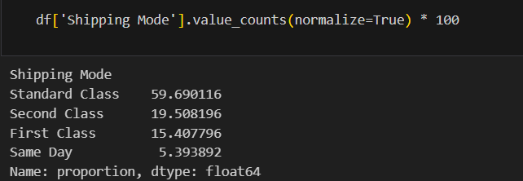
- Shipping Mode Distribution –

- Result – Standard class 59.7%, Second class 19.5%, First class 15.4%, Same day 5.4%
Nearly 60% od orders relied on the slowest shipping option, offering a partial explanation for the delivery time gaps found above.

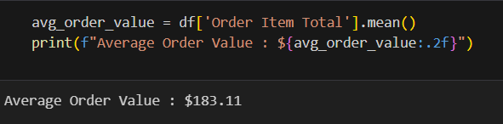
- Average Order Value –

- Result – $183.11
With an average order value $183.11, even small improvements in delivery reliability could meaningfully reduce lost revenue at scale.

- Conclusion –
This analysis demonstrates how a data-driven approach can uncover concrete, actionable insights into logistics performance. Using the DataCo dataset as a practical stand-in for SwiftCart's data, the on-time delivery rate was found to be just 45.17%, with average delivery taking 3.50 days against a scheduled 2.93 days confirming the delivery reliability issues described in the original scenario. Shipping mode analysis revealed a heavy reliance on slower Standard Class shipping (59.7% of orders), pointing to a likely contributor to these delays. With an average order value of $183.11, even modest improvements in on-time performance could meaningfully reduce lost sales and customer dissatisfaction at scale.
These findings support the strategic roadmap outlined earlier: applying regression to forecast demand, clustering to segment regions by delivery behavior, and optimization to improve routing and shipping-mode allocation would directly address the gaps identified here. For SwiftCart's leadership, this kind of analysis would shift decision-making away from guesswork and toward measurable, targeted interventions prioritizing which regions or shipping modes need the most attention before the next peak season.

